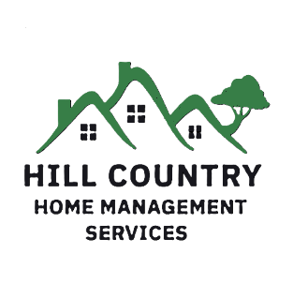
Services:
Construction Management $1,500 per week
Hill Country Home Management Services can help you navigate all phases of your project from design creation to budgeting, material selection, permitting and construction. We can meet with your architect, designer, contractor, and their subcontractors to keep you informed throughout the process.
Hill Country Home Management Services will act on your behalf to ensure all contractors are keeping your best interests in mind.

Property Maintenance & Oversight Weekly Home Visit $750 per month
Monthly Home Visit $375 per month
Hill Country Home Management Services will manage your maintenance needs for you. We will visit your property weekly or monthly to personally assure that your vendors are on point. We will create a custom maintenance schedule for your home, continuously monitor it, and work with your service providers to ensure all maintenance is performed properly and on time.
System Maintenance Includes-
HVAC Septic Systems
Plumbing Water Wells
Landscaping Irrigation
Pools Appliances
Home Repairs, Upgrades, and Special Projects Priced per job
Hill Country Home Management Services can also help you with other small yet necessary tasks. We can assist with appliance repairs or replacement, storage area and garage organization, landscape and hardscape projects, and similar home improvement tasks. We can also help you manage downsizing or relocation if needed. At HCHMS we can help you address minor repairs as well as assist in completing your Honey-Do list so you can enjoy more of your free time.

